## Wago I/O system 750

### Specification

#### Procedure

Wherever possible, the components are to be stored in their original packaging. Likewise, the original packaging provides optimal protection during transport.

When assembling or repacking the components, the contacts must not be soiled or damaged. The components must be stored and transported in appropriate containers/packaging. Thereby, the ESD (Electrostatic Discharge) information is to be regarded.

Statically shielded transport bags with metal coatings are to be used for the transport of open components for which soiling with amine, amide and silicone has been ruled out, e.g. 3M 1900E.

#### Manufacturing number

The manufacturing number indicates the delivery status directly after production. This number is part of the lateral marking on the component.

In addition, starting from calendar week 43/2000 the manufacturing number is also printed on the cover of the configuration and programming interface of the field bus coupler or controller.

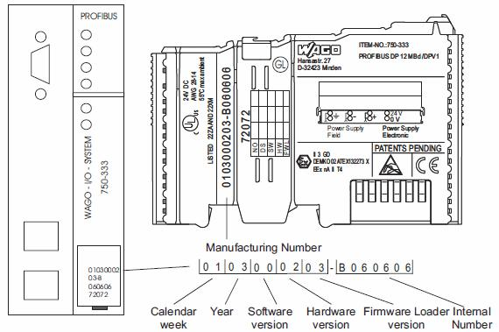

Figure 2‑11: Manufacturing number

#### General description

The WAGO I/O system is a modular, field bus independent I/O system.

It is comprised of a field bus coupler/controller (1) and connected field bus modules (2) for any type of signal. Together, these make up the field bus node. The end module (3) completes the node.

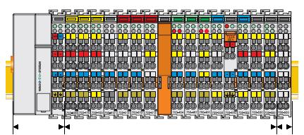

1 2 3

Figure 2‑12: Field bus Independent I/O system

Couplers/controllers for field bus systems such as PROFIBUS, INTERBUS, ETHERNET TCP/IP, CAN (CAN open, Device Net, CAL), MODBUS, LON and others are available.

The coupler/controller contains the field bus interface, electronics and a power supply terminal. The field bus interface forms the physical interface to the relevant field bus. The electronics process the data of the bus modules and make it available for the field bus communication. The 24 V system supply and the 24 V field supply are fed in via the integrated power supply terminal.

The field bus coupler communicates via the relevant field bus. The programmable field bus controller (PFC) enables the implementation of additional PLC functions.

Bus modules for diverse digital and analog I/O functions as well as special functions can be connected to the coupler/controller. The communication between the coupler/controller and the bus modules is carried out via an internal bus.

The system has a clear port level with LEDs (see  3.1.3) for status indication, insertable mini WSB markers and pullout group marker carriers.

The 3-wire technology supplemented by a ground wire connection allows for direct sensor/ actuator wiring.

#### Dimensions

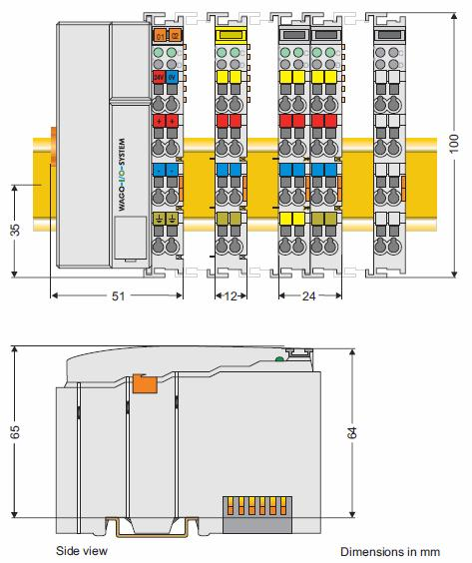

Figure 2‑13: Dimensions

#### Installation position

Along with horizontal and vertical installation, all other installation positions are allowed.

NOTE

In the case of vertical assembly, an end stop has to be mounted as an additional safeguard against slipping.

WAGO item 249-116 End stop for DIN 35 rail, 6 mm wide

WAGO item 249-117 End stop for DIN 35 rail, 10 mm wide.

#### Total expansion

The length of the module assembly (including one end module of 12 mm width) that can be connected to the coupler/controller is 780 mm. When assembled, the I/O modules have a maximum length of 768 mm.

**Examples:**

64 I/O modules of 12 mm width can be connected to one coupler/controller 32 I/O modules of 24 mm width can be connected to one coupler/controller.

**Exception:**

The number of connected I/O modules also depends on which type of coupler/ controller is used. For example, the maximum number of I/O modules that can be connected to a Profibus coupler/controller is 63 without end module.

The maximum total expansion of a node is calculated as follows:

**WARNING**

**The maximum total length of a node without coupler/controller must not exceed 780 mm. Furthermore, restrictions made on certain types of couplers/controllers must be observed (e.g. for Profibus).**

#### Assembly onto a carrier rail

All system components can be snapped directly onto a carrier rail in accordance with the European standard EN 50022 (DIN 35).

*NOTE*

*Carrier rails have different mechanical and electrical properties. For the optimal system setup on a carrier rail, certain guidelines must be observed:*

The material must be non-corrosive

Most components have a contact to the carrier rail to ground electromagnetic disturbances. In order to avoid corrosion, this tin-plated carrier rail contact must not form a galvanic cell with the material of the carrier rail, which generates a differential voltage above 0.5 V (saline solution of 0.3% at 20°C)

The carrier rail must optimally support the EMC measures integrated into the system and the shielding of the bus module connections

A sufficiently stable carrier rail should be selected and, if necessary, several mounting points (every 20 cm) should be used in order to prevent bending and twisting (torsion).

The geometry of the carrier rail must not be altered in order to secure the safe hold of the components. In particular, when shortening or mounting the carrier rail, it must not be crushed or bent

The base of the I/O components extends into the profile of the carrier rail. For carrier rails with a height of 7.5 mm, mounting points are to be riveted under the node in the carrier rail (slotted head captive screws or blind rivets).

#### Spacing

The spacing between adjacent components, cable conduits, casing and frame sides must be maintained for the complete field bus node.

The spacing creates room for heat transfer, installation or wiring. The spacing to cable conduits also prevents conducted electromagnetic interferences from influencing the operation.

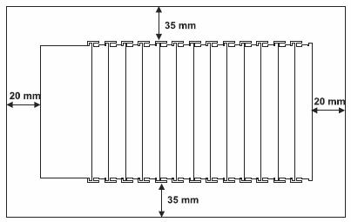

Figure 2‑14: Spacing

#### Installation and removal of the components

WARNING

Before working on the components, turn off the voltage supply.

In order to safeguard the coupler/controller from jamming, it should be fixed onto the carrier rail with the locking disc to do so, push on the upper groove of the locking disc using a screwdriver. To pull out the field bus coupler/controller, release the locking disc by pressing on the bottom groove with a screwdriver and then pulling the orange colored unlocking lug.

|  |  |  |  |
| --- | --- | --- | --- |
| Fix | Locking disc | Release lug |  |
|  |  |  |
|  | Loosen |  |  |

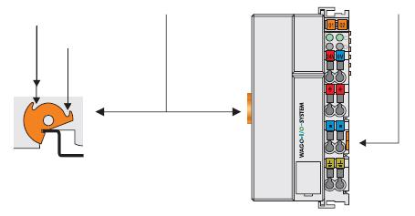

Figure 2‑15: Coupler/controller and unlocking lug

It is also possible to release an individual I/O module from the unit by pulling an unlocking lug.

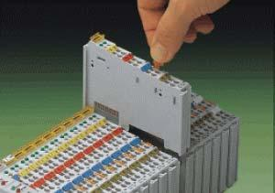

Figure 2‑16: Removing of bus terminal

#### Assembly sequence

**WARNING**

Never plug bus modules from the direction of the end terminal. A ground wire power contact, which is inserted into a terminal without contacts, e.g. a 4-channel digital input module, has a decreased air and creepage distance to the neighboring contact.

Always terminate the field bus node with an end module (750-600).

The reliable positioning and connection is made using a tongue and groove system. Due to the automatic locking, the individual components are securely seated on the rail after installing. Starting with the coupler/controller, the bus modules are assembled adjacent to each other according to the project planning. Errors in the planning of the node in terms of the potential groups (connection via the power contacts) are recognized, as the bus modules with power contacts (male contacts) cannot be linked to bus modules with fewer power contacts.

#### Internal bus / data contacts

WARNING

Do not touch the gold spring contacts on the I/O modules in order to avoid soiling or scratching.

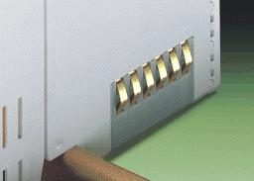

Figure 2‑17: Data contacts

#### ESD (Electrostatic Discharge)

CAUTION

The modules are equipped with electronic components that may be destroyed by electrostatic discharge. When handling the modules, ensure that the environment (persons, workplace and packing) is well grounded. Avoid touching conductive components, e.g. gold contacts.

#### Power contacts

CAUTION

The power contacts are sharp-edged. Handle the module carefully to prevent injury.

Please take into consideration that some bus modules have no or only a few power jumper contacts. The design of some modules does not allow them to be physically assembled in rows, as the grooves for the male contacts are closed at the top.

Self-cleaning power contacts are situated on the side of the components, which further conduct the supply voltage for the field side. These contacts come as touch proof spring contacts on the right side of the coupler/controller and the bus module. As fitting counterparts the module has male contacts on the left side.

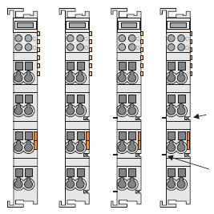

Spring contact in the slot for blade contact

Blade contact

#### Wire connection

All components have CAGE CLAMP® connections.

The WAGO CAGE CLAMP® connection is appropriate for solid, stranded and fine–stranded conductors. Each clamping unit accommodates one conductor.

**Figure 2-7: CAGE CLAMP® connection**

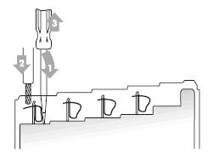

Figure 2‑18: CAGE CLAMP® connection

The operating tool is inserted into the opening above the connection. This opens the CAGE CLAMP®. Subsequently the conductor can be inserted into the opening. After removing the operating tool, the conductor is safely clamped.

More than one conductor per connection is not permissible. If several conductors have to be made at one connection point, then they should be made away from the connection point using WAGO

Terminal Blocks. The terminal blocks may be jumpered together and a single wire brought back to the I/O module connection point.

*NOTE*

*If it is unavoidable to jointly connect 2 conductors, then a ferrule must be used to join the wires together.*

|  |  |
| --- | --- |
| **Ferrule** |  |
| Length | 8 mm |
| Nominal cross section (max.) | 1 mm2 for 2 conductors with 0.5 mm2 each |
| WAGO Product | 216-103 or products with comparable properties |

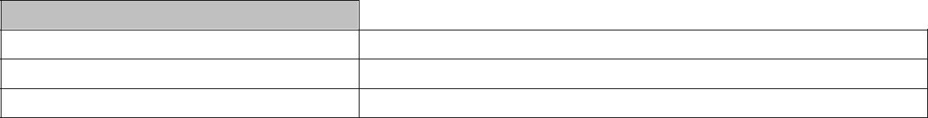

#### Connection

*NOTE*

*The use of an incorrect supply voltage or frequency can cause severe damage to the component.*

The system requires a 24 V direct current system supply (-15% or +20 %). The power supply is provided via the coupler/controller and, if necessary, in addition via the internal system supply modules (750-613).

The voltage supply is reverse voltage protected.

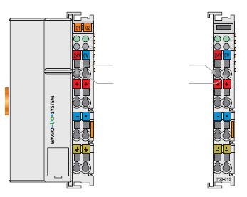

**System supply**

24 V (-15% / +20%)

0 V

Figure 2‑19: System supply

The direct current supplies all internal system components, e.g. coupler/controller electronics, field bus interface and bus modules via the internal bus (5 V system voltage). The 5 V system voltage is electrically connected to the 24 V system supply.

*NOTE*

*Resetting the system by switching on and off the system supply, must take place simultaneously for all supply modules (coupler/controller and 750-613).*

|  |  |
| --- | --- |
| 750-xxx /-8xx | 750-613 |

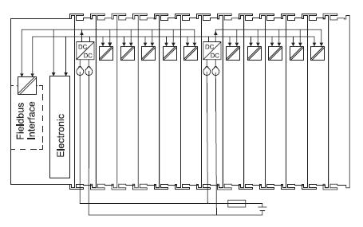

DC 5 V 0 V

DC 24 V (-15% / +20%)

Figure 2‑20: System voltage

#### Connection

Sensors and actuators can be directly connected to the relevant channel of the bus module in 1-/4 conductor connection technology. The bus module supplies power to the sensors and actuators. The input and output drivers of some bus modules require the field side supply voltage.

The coupler/controller provides field side power (24 VDC). In this case it is a passive power supply without protection equipment.

Power supply modules are available for other potentials, e.g. 230 VAC. Likewise, with the aid of the power supply modules; various potentials can be set up. The connections are linked in pairs with a power contact.

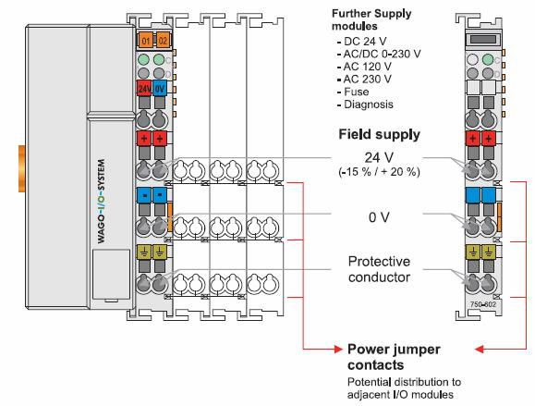

Figure 2‑21: Field supply (sensor/actuator)

NOTE

Some bus modules have no or very few power contacts (depending on the I/O function). Due to this, the passing through of the relevant potential is disrupted. If a field supply is required for subsequent bus modules, then a power supply module must be used. Note the data sheets of the bus modules.

In the case of a node setup with different potentials, e.g. the alteration from 24 VDC to 230 VAC, a spacer module should be used. The optical separation of the potentials acts as a warning to heed caution in the case of wiring and maintenance works. Thus, the results of wiring errors can be prevented.

The supply voltage for the field side is automatically passed to the next module via the power jumper contacts when assembling the bus modules.

The current load of the power contacts must not exceed 10 A on a continual basis. The current load capacity between two connection terminals is identical to the load capacity of the connection wires.

By inserting an additional power supply module, the field supply via the power contacts is disrupted. From there a new power supply occurs which may also contain a new voltage potential.

#### Fusing

Internal fusing of the field supply is possible for various field voltages via an appropriate power supply module.

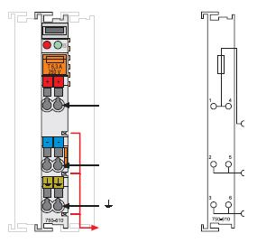

Supply via

Jumper contacts

1. V GND

Figure 2‑22: Supply module with fuse carrier

WARNING

In the case of power supply modules with fuse holders, only fuses with a maximum dissipation of 1.6 W (IEC 127) must be used.

|  |  |  |
| --- | --- | --- |
| **Module** | **Voltage** | |
| 750-601 | 24 VDC, supply/fuse | |
| 750-609 | 230 | VAC, supply/fuse |
| 750-615 | 120 | VAC, supply/fuse |
| 750-610 | 24 VDC, supply/fuse/diagnosis | |
| 750-611 | 230 | VAC, supply/fuse/diagnosis |

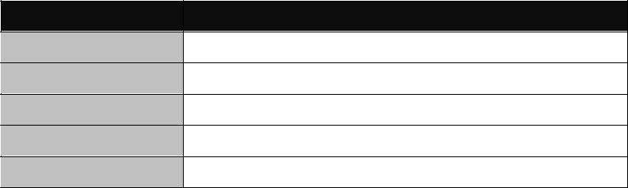

In order to insert or change a fuse, or to switch off the voltage in succeeding bus modules, the fuse holder may be pulled out. In order to do this, use a screwdriver for example, to reach into one of the slits (one on both sides) and pull out the holder.

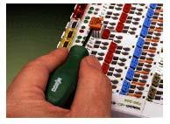

Figure 2‑23: Removing the fuse carrier

Lifting the cover to the side opens the fuse carrier

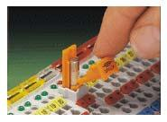

Figure 2‑24: Opening the fuse carrier

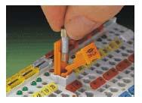

Figure 2‑25: Change fuse

After changing the fuse, the fuse carrier is pushed back into its original position.

#### Grounding the DIN rail

**CAUTION**

**Care must be taken to ensure the flawless electrical connection between the carrier rail and the frame or housing in order to guarantee sufficient grounding.**

When setting up the framework, the carrier rail must be screwed together with the electrically conducting cabinet or housing frame. The framework or the housing must be grounded. The electronic connection is established via the screw. Thus, the carrier rail is grounded.

#### Insulated assembly

Insulated assembly has been achieved when there is constructively no direct conduction connection between the cabinet frame or machine parts and the carrier rail. Here the earth must be set up via an electrical conductor.

The connected grounding conductor should have a cross section of at least 4 mm2.

**Recommendation**

The optimal insulated setup is a metallic assembly plate with grounding connection with an electrical conductive link with the carrier rail.

The separate grounding of the carrier rail can be easily set up with the aid of the WAGO ground wire terminals.

|  |  |
| --- | --- |
| **Article #** | **Description** |
|  | Single-conductor ground (earth) terminal block make an automatic contact to the |
| 283-609 | carrier rail; conductor cross section: 0.2 -16 mm2 |
|  | *NOTE: Also order the end and intermediate plate (283-320)* |

#### Grounding function

The grounding function increases the resistance against disturbances from electro-magnetic interferences. Some components in the I/O system have a carrier rail contact that dissipates electro-magnetic disturbances to the carrier rail.

**CAUTION**

**Care must be taken to ensure the direct electrical connection between the carrier rail contact and the carrier rail. The carrier rail must be grounded.**

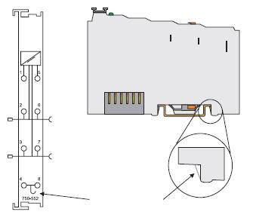

DIN rail contact

Figure 2‑26: Carrier rail contact

#### Shielding (screening)

CAUTION

Constant shielding is absolutely required in order to ensure the technical specifications in terms of the measurement accuracy.

The data and signal conductors should be separated from all high-voltage cables. The cable shield should be potential. With this, incoming disturbances can be

easily diverted.

The shielding should be placed over the entrance of the cabinet or housing in order to already repel disturbances at the entrance.

The shielding of the data and signal conductors reduces electromagnetic interferences thereby increasing the signal quality. Measurement errors, data transmission errors and even disturbances caused by over-voltage can be avoided.

#### Bus conductors

The shielding of the bus conductor is described in the relevant assembly guidelines and standards of the bus system.

#### Signal conductors

NOTE

For better shield performance, the shield should have previously been placed over a large area. The WAGO shield connection system is suggested for such an application.

This suggestion is especially applicable when the equipment can have even current or high impulse formed currents running through it (for example through atmospheric end loading).

Bus modules for most analog signals along with many of the interface bus modules include a connection for the shield.

#### WAGO Shield (screen) connecting system

The WAGO shield connecting system includes a shield clamping saddle, a collection of rails and a variety of mounting feet. Together these allow many different possibilities.

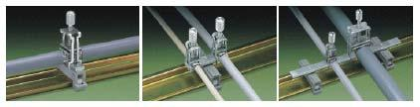

Figure 2‑27: WAGO shield (screen) connecting system

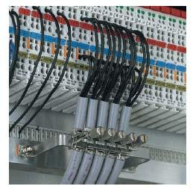

Figure 2‑28: Application of WAGO shield (screen) connecting system

#### Assembly guidelines / standards

|  |  |
| --- | --- |
| **DIN 60204** | Electrical equipping of machines |
| **DIN EN 50178** | Equipping of high-voltage systems with electronic components |
|  | (replacement for VDE 0160) |
| **EN 60439** | Low voltage – switch box combinations |

#### Hardware

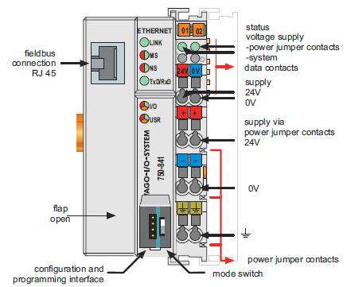

Figure 2‑29: Field bus controller Ethernet TCP/IP

The field bus controller comprises of:

Device supply with internal system supply module for the system supply as well as power jumper contacts for the field supply via assembled I/O modules

Field bus interface with the bus connection

Display elements (LEDs) for status display of the operation, the bus communication, the operating voltages as well as for fault messages and diagnosis

Configuration and programming interface Operating mode switch

Electronics for communication with the I/O modules (internal bus) and the field bus interface.

#### Device supply

The supply is via fed in via terminal blocks with CAGE CLAMP® connection. Device supply is intended for system supply and field side supply.

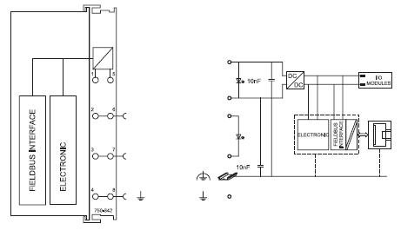

|  |  |
| --- | --- |
|  | 24 V |
| 24 V / 0 V |  |
|  | 0 V |
| 24 V | 24 V |
| 0 V | 0 V |

Figure 2‑30: Device supply

The integrated internal system supply module generates the necessary voltage to supply the electronics and the connected I/O modules.

The field bus interface is supplied with electrically isolated voltage from the internal system supply module.

#### Field bus connection

Connection to the field bus is by a RJ45 connector. A category 5, shielded/unshielded twisted pair cable (S-UTP) with an impedance of 100-Ohm ±15% is mandatory as a connecting line for the 10BaseT Interface.

The connection point is physically lowered for the coupler/controller to fit in an 80 mm high switch box once connected.

The electrical isolation between the field bus system and the electronics is achieved by means of DC/DC converters and optocouplers in the field bus interface.

|  |  |  |
| --- | --- | --- |
| **Contact** | **Signal** |  |
| 1 | TD + | Transmit + |
| 2 | TD - | Transmit + |
| 3 | RD + | Receive + |
| 4 |  | Free |
| 5 |  | Free |
| 6 | RD - | Receive - |
| 7 |  | Free |
| 8 |  | Free |

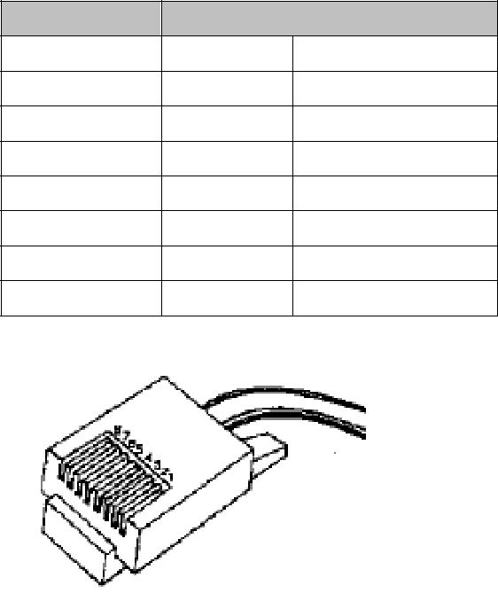

Figure 2‑31: RJ45 connector

NOTE

Only for use in LAN, do not for telecommunication circuit connections.

#### Display elements

The operating condition of the field bus controller or node is displayed via light diodes (LED). For more detailed information, please refer to the *“WAGO Ethernet TCP/IP 750-881 Manual”*.

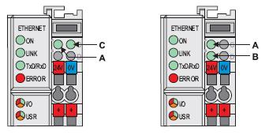

Figure 2‑32: Display elements

|  |  |  |  |  |  |  |  |
| --- | --- | --- | --- | --- | --- | --- | --- |
|  | **LED** |  |  | **Color** |  | **Meaning** |  |
|  |  |  |  | Green |  | Field bus initialization is correct. |  |
|  | **ON** |  |  |  |  |
|  |  |  |  |  |  |  |
|  |  |  | Off |  | Field bus initialization is not correct, no function or self- |  |
|  |  |  |  |  |
|  |  |  |  |  | test. |  |
|  |  |  |  |  |  |  |
|  | **LINK** |  |  | Green |  | Link to a physical network exists. |  |
|  |  |  | Off |  | No link to a physical network. |  |
|  |  |  |  |  |  |
|  | **TxD / RxD** |  |  | Green |  | Data exchange taking place. |  |
|  |  |  |  |  |
|  |  |  | Off |  | No data exchange. |  |
|  |  |  |  |  |  |
|  | **ERROR** |  |  | Red | Error on the field bus. | |  |
|  |  |  | Off |  | No error on field bus, normal operation. |  |
|  |  |  |  |  |  |
|  |  |  |  | Green |  | Field bus controller operating perfectly, data cycle on |  |
|  |  |  |  |  | the internal bus. |  |
|  |  |  |  |  |  |  |
|  |  |  |  |  |  |  |  |
|  |  |  |  | Off |  | No data cycle on the internal bus. |  |
|  |  |  |  |  |  | 1. During startup of field bus controller: Internal |  |
|  | **I/O** |  |  |  |  | bus being initialized, startup displayed by |  |
|  |  |  |  |  |  | LED flashing fast for approx. 1-2 seconds |  |
|  |  |  |  | Red |  | 2. After startup of field bus controller: Errors, |  |
|  |  |  |  |  |  | which occur, are indicated by three |  |
|  |  |  |  |  |  | consecutive flashing sequences. There is a |  |
|  |  |  |  |  |  | short pause between each sequential flash. |  |
|  | **USR** |  |  | Red / Green / Orange |  | The “USR” LED can be selected by a user program in a |  |
|  |  |  |  | programmable field bus controller. |  |
|  |  |  |  |  |  |  |
|  | **A** |  |  | Green |  | Status of the operating voltage – system |  |
|  | **B or C** |  |  | Green | Status of the operating voltage – power jumper contacts | |  |
|  |  |  | (LED position is manufacturing dependent). | |  |
|  |  |  |  |  |  |

#### Display elements (power supply filter 24 VDC - 750-626)

**WARNING**

**The maximum current of the filter module is 10 A. When configuring the system it is important not to exceed the maximum/sum current. However, if such a case should occur, another supply module must be added.**

The filter module 750-626 can be used with all couplers/controllers of the WAGO-I/O-SYSTEM 750.

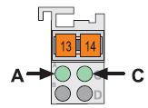

Figure 2‑33: Display elements (power supply filter 24 VDC - 750-626)

|  |  |  |  |  |  |  |  |  |
| --- | --- | --- | --- | --- | --- | --- | --- | --- |
|  | **LED** |  |  | **Designation** |  | **State** | **Function** |  |
|  | **A** |  |  | Status | | Off | No 24 VDC system voltage supply. |  |
|  |  |  | Voltage supply | |  |  |  |
|  | **(green)** |  | - | |  |  |  |  |
|  |  |  |  | System | | On | 24 VDC system voltage supply. |  |
|  |  |  |  |  | |  |  |  |
|  | **C** |  |  | Status voltage | | Off | No 24 VDC voltage supply via |  |
|  |  |  | Supply | |  | power jumper contacts. |  |
|  | **(green)** |  | - | |  |  |  |  |
|  |  |  |  | Power jumper | |  |  |  |
|  |  |  |  | Contacts. | | On | 24 VDC voltage supply via |  |
|  |  |  |  |  |  |  | power jumper contacts. |  |
|  |  |  |  |  |  |  |  |  |

#### Technical specifications

|  |  |
| --- | --- |
| **System data** |  |
| No. of nodes | Limited by ETHERNET specification |
| Transmission medium | Twisted Pair S-UTP 100 Ω cat. 5 |
| Bus coupler connection | RJ45 |
| Max. length of field bus segment | 100 m between hub station and 750-841; max. length of |
|  | network limited by ETHERNET specification |
| Baud rate | 10/100 Mbit/s |
| Protocols | MODBUS/TCP (UDP), ETHERNET/IP, HTTP, BootP, |
|  | DHCP, DNS, SNTP, FTP, SNMP |
| Programming | WAGO -I-PRO CAA |
| IEC 61131-3-3 | IL, LD, FBD, ST, SFC |
| **Technical data** |  |
| No. of I/O modules | 64 |
| with bus extension | 250 |
| Field bus: |  |
| Input process image max. | 2 kByte |
| Output process image max. | 2 kByte |
| Input variables max. | 512 Byte |
| Output variables max. | 512 Byte |
| Configuration possibility | Via PC |
| Program memory | 512 kByte |
| Data memory | 256 kByte |
| Non- volatile memory | 24 kByte (16 k retain, 8 k flags) |
| Max. no. of socket connections | 3 HTTP, 15 MODBUS/TCP, 10 FTP, 2 SNMP, |
|  | 5 for IEC 61131-3 programs, |
|  | 2 for WAGO-I/O-PRO |
| Power fail-RTC -Buffer | Min. 6 days |
| Voltage supply | 24 VDC (-25 % / + 30 %) |
| Input currentmax | 500 mA at 24 V |
| Efficiency of the power supply | 87 % |
| Internal current consumption | 300 mA at 5 V |
| Total current for I/O modules | 1700 mA at 5 V |
| Isolation | 500 V system/supply |
| Voltage via power jumper contacts | 24 VDC (-25 % / + 30 %) |
| Current via power jumper | DC 10 A |
| contactsmax |  |
| Dimensions (mm) W x H x L | 51 x 65* x 100 (*from upper edge of DIN 35 rail) |
| Weight | ± 184 g |
| **Accessories** |  |
| WAGO-I/O-PRO 32 or | 759-332 |
| WAGO-I/O-PRO CAA | 759-333 |

### Installation

The basic wago will consist of the following modules as seen in the overview (see Figure 2‑34).

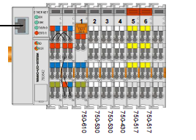

Figure 2‑34: PLC overview

#### PLC explanation and settings

In the following exploded views (see Figure 2‑35 and Figure 2‑36) you can see which fields are attached to which PLC slide. These settings suffice the mandatory rules as stated in MSC128(75).

These fields are also described in the Product description v1.2 and can be subdivided in the following:

6* WAP 1st stage

4* WAP 2nd stage

4* WAP 3rd stage

6* Timer reset button

1* Stage 1 alarm out to VDR

1* Stage 2 alarm out to VDR

1* Stage 3 alarm out to VDR

1* Common failure alarm out

1* in BNWAS on/off

1* in BNWAS auto

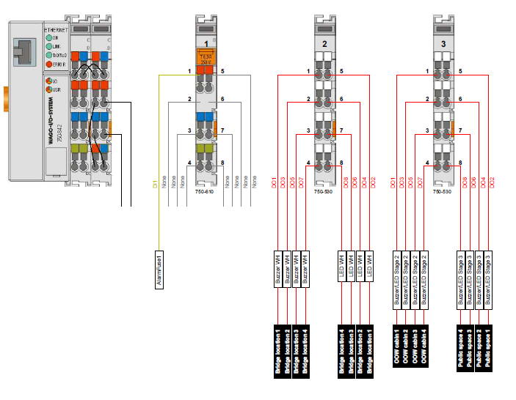

Figure 2‑35: Exploded view 1

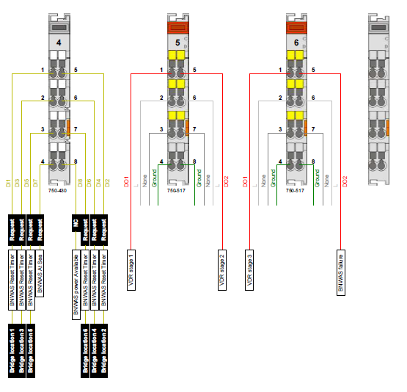

Figure 2‑36: Exploded view 2